ALLSAFE COMFORT

Dog safety
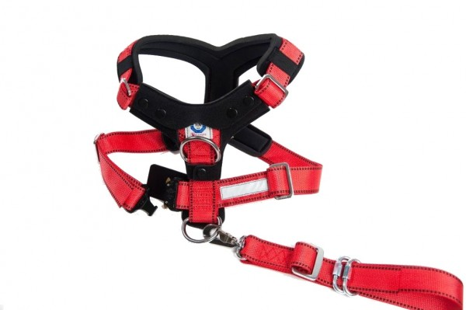
Error! Filename not specified.
Error! Filename not specified.
Error! Filename not specified.
Error! Filename not specified.
Error! Filename not specified.
Error! Filename not specified.
Error! Filename not specified.
- Crash Tested
- TÜV Tested
- Maximum Safety for Dog and Passengers
- Attaches Easily to the Vehicle Seat Belt with One Hand
- AustriAlpin Cobra Quick Release for Optimal Safety & Ease of Use
- High Strength Tear-Resistant Polyester Harness
- Extremely High Load Capacity
- Coated Steel Connectors
- Soft Padding Alleviates Pressure Points
- Excellent for use as a Walking Harness
- Animal Friendly Design
- Additional Safety Provided with Reflection Strips
- Adjustable Tether with Rotating Carabiner for Safety & Comfort

ITEM DESCRIPTION
The AllSafe Comfort - Dog Safety Harness is the most comfortable, secure and safest choice for you and your four-legged passenger!
The technically sophisticated design was developed in Germany by a company with 18 years of experience in the design of Crash Tested Pet Safety Harnesses.
The AllSafe Comfort has been built and constructed using only the highest quality materials including the use of a high strength polyester fabric developed in cooperation with veterinarians.
Special soft padding and a wide chest plate alleviate pressure points and provide comfort, security and safety for your dog.
High load capacity coated steel connectors assure the safety of your dog even under the most extreme conditions in a crash.
TÜV tested in Germany according to published safety standards ECE R-17 and ISO27955.
Tested to withstand a minimum of 4,410lb / 2,000kg - Sizes M, L, XL
Tested to withstand a minimum 2,205lb / 1,000kg - Size S
The patented AustriAlpin Cobra Quick Release allows the AllSafe Comfort to be easily and quickly put on and removed from your dog.

The patented AustriAlpin Cobra buckle is the only stab-lock style fastener on the market that will not open while under load. Designed and manufactured in Tyrol, Austria meeting the following specifications:

SPECIFICATIONS
-Exceeds EN 358
-Exceeds ANSI z359.1
-Exceeds CSA z259.1
-Exceeds NFPA 1983/2006
-Exceeds Mil-Spec Salt Fog, Blowing Dust and Sand Tests
-ISO Quality Control [89/686/EEC Art.11B]
The AllSafe Comfort - Dog Safety Harness easily attaches to the safety belt in your vehicle keeping your dog safe while still allowing the proper amount of movement required for the comfort of your dog.
The AllSafe Comfort is the highest quality Pet Safety Harness on the market designed to provide the maximum safety for dog and passengers.
Available in 4 Sizes
Please note that the AllSafe and AllSafe Comfort run large for their size. Please use our Sizing Guides and measure using the Illustration and Measuring Guidelines.

