DOGWALK ³ ALUMINUM DOG LIGHT, COMPACT & TÜV APPROVED

Three-Piece Telescopic Dog Ramp
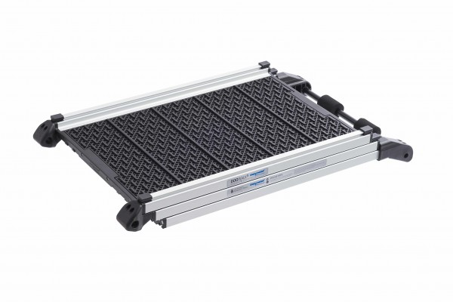

- TÜV Tested in Germany for Quality & Safety
- 3 Piece Collapsible Ramp is Easy to Transport & Use
- High Quality Aluminum Frame & Plastic Surface with Tread Design
- Lightweight, Fast and Simple to Extend & Collapse
Article no.: 14000860

ITEM DESCRIPTION
The DOGWALK ³ is a lightweight, well-designed, high-quality and easy to use three (3) part telescopic dog ramp.
The DOGWALK ³ is manufactured from aluminum with a plastic surface featuring a safety tread design.
The DOGWALK ³ TÜV tested in Germany for safety & quality.
The DOGWALK ³ is suitable for use with an SUV or for dogs that have a joint disease and need the easiest possible entry 9n to a vehicle.
Space saving design can be stowed & deployed quickly and easily.
Includes a practical carrying bag for storage when not in use.
Angled support surface with foam pads to prevent the ramp from slipping and scratching the bumper.
Infinitely Adjustable from 32.7” to 76” with an optimal pitch of 33.5 in when in use.
Width 16.15”
Height 4.72”
Weight 16.3lb.

